Wise Words - Changing Archetypes
Gary Wise

Invariably, with the release of new sets into already established environments, be they Limited or Constructed, the contents of those sets are bound to not only introduce new archetypes but also to change those that already exist. This week's Wise Words examines the Limited archetypes that Odyssey left us with, and how they'll have changed with the addition of Torment.
With the abundance of black and resulting deficiency of white and green in Torment, everyone seems to be jostling for position on the dark side in Odyssey-Odyssey-Torment drafts, which has a number of effects ranging from a limit on how many players can run each archetype effectively, to the way we value assorted sideboard cards and main-deck color hosers and what attitude we approach our first few picks with. Here's hoping that what follows helps you gain a rudimentary understanding of the changes that have occurred and how you should be adjusting yourself accordingly.

The Archetypes

Blue-white control
Crucial cards (Odyssey): Psionic Gift, Aether Burst, creatures with flying
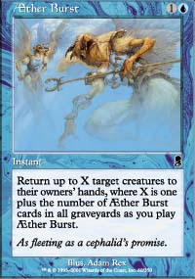
With only two Odyssey packs, it's tougher to find multiple copies of this great card.
The old: In straight Odyssey, this was one of the most popular archetypes, with its strength coming from two of the deeper colors in the format, the synergy between blue's flyers and white's ability to protect creatures and gum up the ground, and the fact that aside from blue, there wasn't really another great partner color for white.
The Odyssey version of this deck found its problems came in the form of cards like Demoralize and Overrun that just couldn't be controlled. Additionally, there was very little in the way of viable life gain. On the plus side, blue-white is definitely better at suppressing aggressive red-green decks than any other color combo, and often finds itself having a strong sideboard thanks to cards like the Spheres, Aura Graft and the like.
Crucial Cards (Torment): Teroh's Faithful, anti-black cards
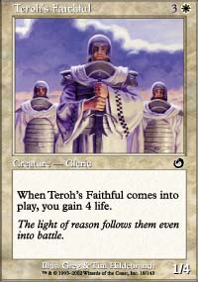
Win the race.
Where white was finding itself underdrafted before, now there's so little to go around that getting enough would seem almost miraculous. Still entirely capable of controlling the board, the diminishing of the Scrivener-Aether Burst engine and weakening of countermagic in Torment means that you probably want to draft blue-white with more of a race temperament.
The best way to do that is to draft what is likely Torment white's best common, Teroh's Faithful, then use it to throw off opposing mathematics. In addition, if you aren't playing black, it's entirely likely you'll play against at least two black decks in three rounds, and no color is better at finding anti-black cards than white. Stern Judge, Strength of Isolation, Teroh's Vanguard... the list goes on.
One strategy I've heard of pros employing is to start blue and look to go black, with blue-white as a fallback plan. Regardless of whether this is the strategy that brings you into blue-white, be very careful with regards to the number of playables you have: if you think you might come in short, it will probably be worth your while to pick up some red or black kill spells.

Red-green beats
Crucial cards (Odyssey): Chatter of the Squirrel, Reckless Charge, Rites of Initiation
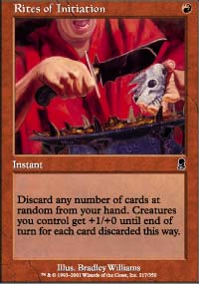
The Rites, like many of the deck's staples, can be gotten late in the draft.
The crucial thing to this archetype's success is the combination of speed and aggression. First and second turn plays are crucial to this deck, which tries to gain the early advantage with fast creatures then win with the swarm.
The red-green deck licks its lips when paired against blue-black but has some problems with the more blockade-minded blue-white, but even in its worst match up can do some early damage with Chatters, Diligent Farmhands, Mad Dogs, Ember Beasts and Wild Mongrels before using Rites of Initiation, burn, Demoralize and Overrun as finishers.
Crucial cards (Torment): Fiery Temper, Acorn Harvest
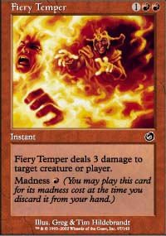
With blue-black's popularity and the diminishing value of green in its wake, this deck should remain viable as its waning popularity should make up for the loss of an Odyssey pack. Unfortunately, Torment doesn't offer as much in the way of aggression as players of this deck would like, but if you're planning on putting together some kind of swarm, Acorn Harvest will do you well. Try it with Rites of Initiation for a good laugh.
In addition to Basking Rootwalla, Torment offers an assortment of effective burn, with Fiery Temper being well complimented by Sonic Seizure, and even Longhorn Firebeast offering itself as a viable option either way your opponent sees it (this may be the only archetype for the card so don't draft it too high). The key to this deck is keeping your mana curve low: if you're building your deck and you have a lot of fours and fives, you probably aren't in good shape.

Green-blue threshold
Crucial cards (Odyssey): Cephalid Looter, Werebear, Diligent Farmhand
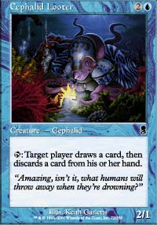
Get the loot, ditch the lands.
For me, there was no question that this was the best archetype in straight Odyssey block, but the problem lay in being able to get the colors in an environment where good drafters knew they were either blue or green. The deck, a cross between aggression and control, uses green threshold cards like Springing Tiger, Krosan Avenger, Seton's Desire and the almighty Werebear in tandem with blue's efficient bounce and graveyard enhancement spells in an attempt to run the opposition over.
What really makes this deck good is the way that its Werebears and Diligent Farmhands not only give it an early game, but also speed up the transition to the midgame. Once the mana is in place, threshold kicks in and then your opponent is in heaps of trouble, especially when you put the Desire on any of your already-great creatures. The moment I opened Cephalid Looter in straight Odyssey, I knew I was likely to be a green-blue mage.
Crucial cards (Torment): Basking Rootwalla, Compulsion
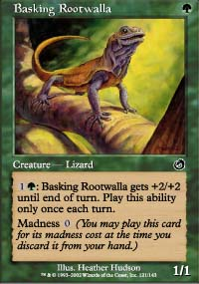
Great in tandem with blue's many discard/search effects.
All of a sudden, instead of 'green or blue', people are thinking 'black' when they head into drafts, and that means that while the deck is weakened a little, it's much more likely to make itself available to you, and when it does so, you should consider it seriously. Very capable of splashing thanks to Looters, Farmhands, Rites of Spring and the like, the deck as I've drafted it has always had that one Mystic Zealot or Ghastly Demise in it, meaning that choosing this direction doesn't actually cut you off from the spoils black offers in Torment. Throw in the especially powerful Skywing Aven and you have a deck that should still be very effective.

Blue-black control
Crucial cards (Odyssey): Gravedigger, Scrivener
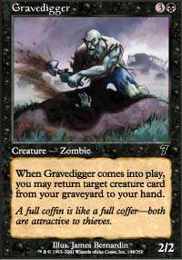
Who builds stronger than the mason, the shipwright or the carpenter?
The longer the games go, the better for this deck. Blue-black was built around bounce, kill, and the incredible card advantage provided by the Gravedigger-Scrivener combo, which could be further enhanced by cards like Malevolent Awakening and Morgue Theft. This long game approach makes this the best deck to play against blue-white, but red-green becomes a real pain without white's ability to stop fast creature approaches with Kirtar's Desire and Angelic Wall. As a result of this weakness, cards like Crypt Creeper and Phantom Whelp find their value enhanced thanks to the deck's desire to stop that annoying second turn Mad Dog.
With seven good commons in the set (Ghastly Demise, Patriarch's Desire, Morbid Hunger, Afflict, Dirty Wererat, Gravedigger and Dusk Imp), Odyssey's black goes a lot deeper than many give it credit for, and the result of this underestimation was that outside of blue-black decks, there wasn't too much black being drafted. If the blue player was able to cut the black off without anyone noticing, winning the table wasn't a stretch.
Crucial cards (Torment): Aquamoeba, Obsessive Search.
Well, things have certainly changed for this archetype, easily the strongest coming out of Torment. Black offers all kinds of amazing goodies in the set, ranging from Faceless Butcher to Crippling Fatigue to Cabal Torturer, and they all require to cast, meaning people won't often be tempted to splash them. On top of that, blue got some more good stuff in the form of the aforementioned Aven, Obsessive Search and Aquamoeba, the great two-drop this archetype desperately needed.
The one problem you'll face drafting blue-black now is that everyone else wants to also. Yes, there's a lot to go around, but there will be tables where six or seven players end up playing the skull, and that could mean that your deck will be watered down quite a bit. As a result, I would draft cards like Peek, Predict and Eggs a little higher. If nothing else, they'll get you to your power cards and fill your graveyard quickly, a must for this deck.

Red-black control
Crucial cards (Odyssey): Firebolt, Morbid Hunger, Innocent Blood
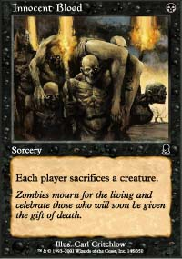
I was never a huge fan of this deck. Green had the flashback creatures and white had Shelter, and when your goal is to kill every creature an opponent puts into play, protective cards that cause you card disadvantage are a real problem.
The idea behind this deck is to use cards like Firebolt and Hunger to take out smaller creatures, leaving that one big critter on the table for Innocent Blood to take out. The deck shouldn't beat down too much, preferring creatures like Zombie Assassin and Chainflinger to add to its quantity of kill in a format where everyone has creatures.
Crucial cards (Torment): Crippling Fatigue
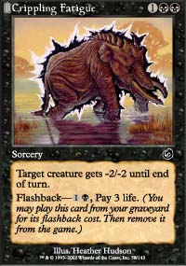
It's worth fighting for this powerhouse.
With everyone wanting blue to go with their black, this is a very solid alternative. Not only will you get uncontested red cards, but a lot of those are cards that are only really playable in this archetype (Pardic Collaborator, Barbarian Outcast), meaning you'll get them late if you pass them early.
The real question now, though is whether red-black should be drafted as a more aggressive deck, with Barbarian Outcast, Sonic Seizure, Longhorn Firebeast and the like all contributing in a more effective way to that kind of deck. If you do go this direction, start treating black cards as you would if you were drafting black-green: their value will be similar in both decks.

The Rest
Blue-red was never a very popular color combo in Odyssey block, and I wouldn't look for that to change much now. Yes, there is potential for a great madness deck, but two packs is a long time to wait to see if you'll get those great red madness cards come Torment time.
White-red takes a big hit this time around, losing a pack's worth of white Odyssey bears and having them replaced with a series of more defensive cards. This deck really wants to be aggressive, but I don't think the creatures exist to draft good red-white consistently.
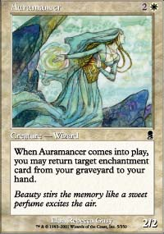
White-black obviously receives a bit of a boost in the black department and takes a hit in the white, but the real problem here is that triple Odyssey white-black was built around Auramancer, Patriarch's Desire and the ability to recur the former, meaning that you'd also recur the latter. While losing out on the combo aspect, the black in Torment is so strong that you shouldn't have problems getting cards, and that means you could conceivably build an excellent metagame deck.
Green-black is a deck I'm not especially fond of in that green and black share a number of strengths and weaknesses, but you can't argue with getting the best color from each set. When drafting this deck, be sure to put an emphasis on your early drops, as in Torment they're few and far between.
Green-white is a huge risk in that you can expect maybe three cards in Torment. If you draft this color combo, I highly recommend splashing a third color, as green's mana diversification and your shallow card pool will make it a natural choice.
That's it for this week. Check out Wise Words a week from now when I discuss how Torment's addition to the Limited environment has changed the individual values of certain Odyssey cards. Have a good one.

Discuss this article on the message boards.

